D840R-How to set a DMZ host？
Product line: ADSL Question category: Function configurations

Q: Why do we want to configure DMZ host?
A：1. In the router set port mapping, port mapping can’t be access remotely, then you can try to open the DMZ host, if you open the DMZ host, the remote can access the port corresponding to the normal service.
2. Don’t know the port number of some kinds of application servers so that you can’t set port mapping, such as network cameras, some database software, etc., then you can open the DMZ host.
3. Can’t play some games when the normal operation (e.g. StarCraft) and you can land normally, but can’t field a team, then you can open the DMZ host.
4. Some special sites cannot open or can’t operate normally, such as certain online banking can’t be transferred, can‘t enter the verification code, etc. You can try to set the DMZ host.

The Connection Topology is as below:
I. Physical connection:
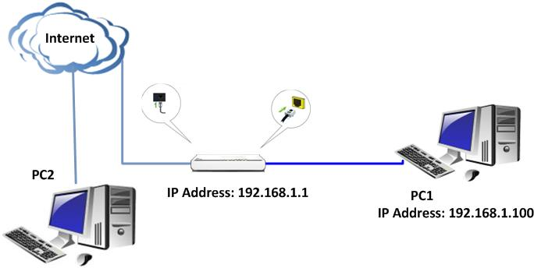
II. Login to the management page of the router:

1. Open a web browser (IE, Firefox, Safari, etc.) and find the address bar, leaving it blank before typing in 192.168.1.1, and then press enter.
(Care: The address bar is in the most top of the web page after opening web browser).
2. Input default username and password: admin in the following window, then click ok.
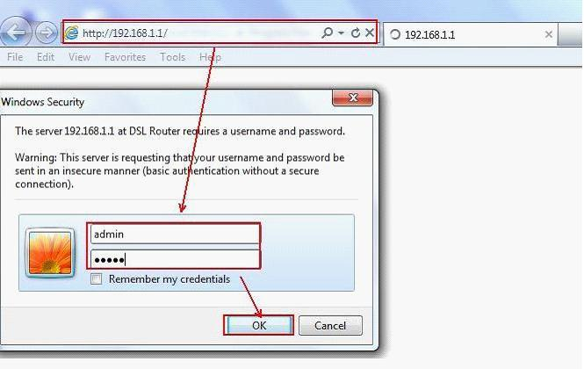
3. Click Advanced setting and then click NAT, then click DMZ host. Please type in the IP address of the computer which you want to set as the DMZ host into the blank and then click Save/Apply to finish it.
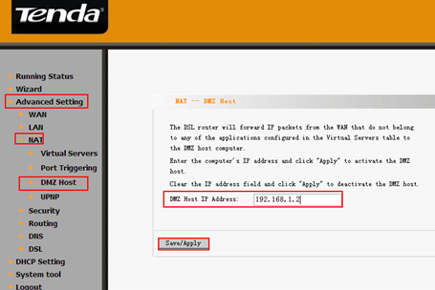
After the settings, computers in the Internet can access the server in DMZ host. For example, according to the topology, computers in the Internet with IP address 2.2.2.2 can access the FTP server in DMZ host by ftp://1.1.1.1.

